HOLY WEEK – TUESDAY

Reflecting on:

“To Know Jesus more intimately
and to Love Him more ardently.”

Biblical Readings:
- Lk 1: 26-38
- Jn 1: 1-18
- Pl 2: 6-11

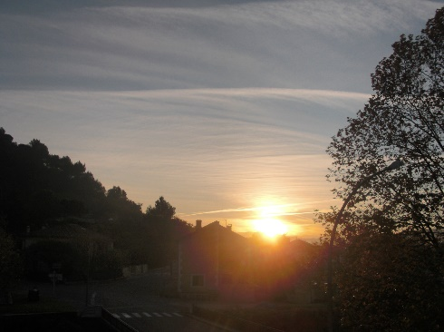
Based on today’s theme, there are a lot of things appearing in my mind: Do I believe in evolution, or in creation, or both? I think of the universe, the galaxies, the planets... Science and faith seem to mix up in my mind. Finally, in my mind’s eye I zoom in on the earth in its shape and contemplate the Incarnation. I pray to be one with the Lord.

I put myself out of this world as far as I can in the universe from where I can see the immensity of the whole universe. I can see so many galaxies. In each galaxy, there are millions of planets and each planet is seemingly like a tiny grain of sand.

I ask myself, “Where is the earth?” I zoom up my view bit-by-bit until I can see the galaxy in which the earth exists. Wow! The galaxy is beautiful and multi-colourful. I can see millions of stars in this galaxy. I zoom up my view again until I see the solar system and the earth turning on itself and around the sun. The sun is much bigger than the earth. It is roughly one million three hundred and forty thousand times as much. It means I can fit more than 1.3 million earths inside the sun. To compare with the sun, the earth seems to be like a grain of sand next to a basket ball. I put myself far away in the universe again and I cannot see where the earth was. In other words, if I look for the earth in the milky galaxy, I cannot find it, let alone in the immensity of the universe!

I ask myself, “Is there any other planet in the universe on which living creatures exist or is there only the earth?” – “In eternity, are there other ‘human beings who have existed on other planets?” – “Is there evolution on earth or just the creation as described in the Holy Bible?” According to some, human beings appeared on earth around 6,000 years ago!

So, “Do I believe in evolution or creation or both?”

Suppose I believe in evolution, “Does God partake in my existence?” – “Yes, He does”. I believe that God is the sole Author of my soul and my mind. My body might come from evolution, but my soul and my mind come from God. In Genesis, God created the earth and its nature. Finally He created Adam and Eve. Scientifically speaking, Adam and Eve (representing human beings) were the climax of evolution. If God did not intervene in human intellectual development, then human beings would be as primitive as other creatures on earth. Therefore, I believe in God’s intervention in terms of the intellectuality of the human mind. In terms of metaphysics and the super-natural, I believe that God gives each human being a soul, because human beings are created in God’s image and therefore they are sacred as compared with other creatures.

Again I put this question, “Why did God test Adam and Eve in a way that enabled them to sin against Him?” – “Why didn’t God let them live happily in a good relationship with Him?” An answer came to my mind about this. God put Adam and Eve to the test by asking them not to eat the fruit of the tree in the middle of the garden. This was the Tree of the Knowledge of good and evil. But this does not mean God laid down conditions as if He was afraid Adam and Eve would become like Him as the serpent had told them (Gn 3: 5). A condition simply means an imposition. Here, God did not impose a rule or a law, but only warned Adam and Eve not to use their knowledge against God. Everything was created by God, even Knowledge. So, everything must be in the circle of God’s providence, love, protection and guidance. The biggest sin of knowledge is pride. One important thing that God wanted Adam and Eve to know was that the knowledge in their mind came from God, not from their own ability. So, they must use their knowledge, their intellectuality, to thank and praise God as well as to create a good relationship with Him. However, the warning of God became a temptation for Adam and Eve. Evil became a force behind them and pushed them towards pride so that they wanted to be like God in the sense of being equal to Him. In doing this, they thought they could put God aside so as to dominate the world. The result however was that the purity of their mind was poisoned by the evil of pride and the relationship between God and the couple Adam and Eve disfigured.

In contemplating how it happened that God became man, I put aside scientific thoughts in order to reflect more deeply on the way that God loves the world. There are so many unsolved questions if I want to use science to solve matters of faith. Faith is a gift from God. It is a mystery. I cannot use science to answer for the mystery of faith. Science belongs to the intellect and knowledge. Faith belongs to the super-natural and the heart in a way that science cannot explain. Therefore, I can only contemplate rather than understand the beauty of God’s love for humanity. In order to take away Adam and Eve’s sin of pride, God humbled himself to become a man like us. And so Jesus Christ, the Son of God and God himself, became man. Unlike Adam who wanted to be equal to God (Gn 3: 5-6), Jesus did not reach out for equality with God (Phil 2: 6-11).

There might be many planets in the universe that have had living creatures. One can assume God has had a plan for them as well. But as far as earth is concerned, God has chosen the earth as his foot-stool to let the universe know that there are Three Persons in One God. God exists from eternity and the Second Person in One God became man in order to save the fallen world and to reveal the true image of the Triune God.

The more I reflect on the immensity of the universe, the more I feel the eternity of God.

Asking for a Grace:

Lord Jesus, I ask you to help me contemplate God’s splendour deeper and deeper every day, particularly the beauty of God’s image through you, my Lord Jesus Christ.

May I be generous in judging others as you are generous in judging me.
May I be patient with others as you are with me.
May I be humble in my life as you lived and showed your humility in your life.
May I be gentle in my action and reactions as you are my example.
Amen.

